| What is a market? | A place where producers sell goods or services, where consumers buy goods of service . |
| --- | --- |

Insert your photo of the Simple Circular Flow of the Economy Diagram

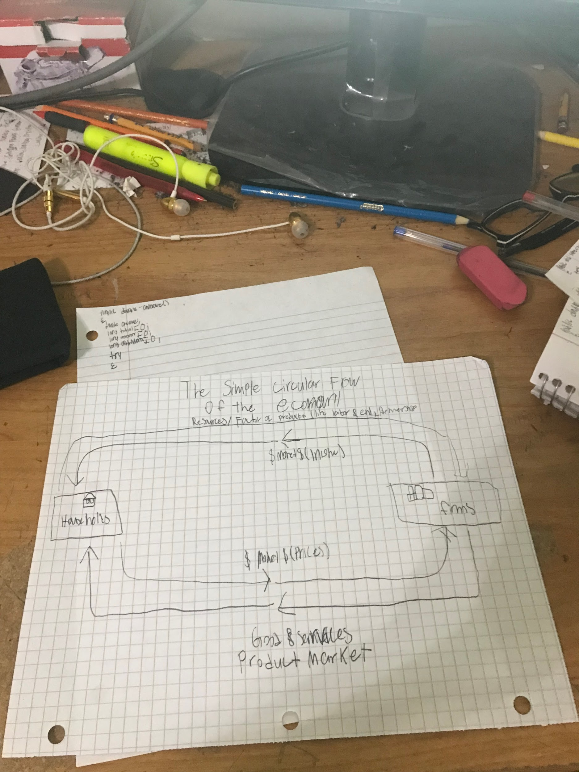

| What is Microeconomics? | Microeconomic is making an economic decision for a individual person, individual family, a small business, and industry, decision making at a local level  Supply and Demand and decision-making at a local level  A person  A family  A business  A industry |
| --- | --- |

| Explain what Macroeconomics is | Macroeconomics is the study of the large economy as a whole. It is the study of the big picture.  Instead of analyzing 1 consumer, we analyze everyone, instead of 1 business we study all businesses |
| --- | --- |

| What happened that brought about the need to study Macroeconomics? | The field of macroeconomics was born during the great depression. The great depression was when there was FDR become president and gace aid |
| --- | --- |

| Type one sentence about something you remember about the Great Depression | During the great depression, there was a huge unemployment rate, people were broke, Herbert Hoover was the US President who refused to give aid to the poor and in the 1932 Election, FDR beat Hoover in a landslide and during his First 100 Days in 12 year office, FDR decided to make reforms to the economy |
| --- | --- |

| Why is studying macroeconomics important? | The field of macroeconomics was born during the great depression  Government didn’t understand how to fix a depressed economy with 25% unemployment ate  Macro was created to:  -measure the health of the whole economy  -guide government policies to fix problems |
| --- | --- |

| What is something that you’d like to see from your toddler that makes you think that your toddler is healthy? | I want to see my future child eat healthy, avoid eating junk food, perform well in school, and make good decisions in pre school, try your best in everything |
| --- | --- |

| 3 Goals of Most Economies |  |
| --- | --- |
|  | 1)GDP(Growth) |
|  | 2)Control Inflation |
|  | 3)Limit Unemployment |

| What is the definition of Gross Domestic Product? | Gross Domestic Product(GDP) is the dollar value of all final goods and services produced within a country’s borders in one year |
| --- | --- |

| What is the acronym that represents what GDP is composed of? | Country’s income, Just like calculating your own income, GDP measures how well the U.S. is doing financially  GDP is composed of data from 4 major categories  C + I + G + (X - M) |
| --- | --- |

| Insert a photo of something that represents the last American made good or service you spent money on | Custom Sticky Notes, Size: 3x3,7x3, Rs 55 /pack Instawings India Pvt Ltd |  ID: 22645043612 |
| --- | --- |

| Consumer Expenditures - Explain | Any domestic items or services that are made for final consumption for consumers are considered consumer spending  Ex: School Supplies, foods, haircuts  This is the largest of the 4 components to America's GDP. |
| --- | --- |

| Investment Goods - Explain | Business Expenses  Businesses Invested  Businees spend money for their business  Ex: Tools |
| --- | --- |

| Submit a photo of something a business will invest in | How do I get my landlord to make repairs? - PhillyTenant.Org |
| --- | --- |

| Government Expenditures - Explain | Government purchases are included in the GDP  Ex:Health Insurance,  Transfer Payments do not count(Social Security, Welfare, etc) |
| --- | --- |

| Submit a photo of something that the US government purchases | Californians Without Health Insurance Will Pay A Penalty — Or Not |  California Healthline |
| --- | --- |

| What government expenditure does NOT count towards our GDP? | Social Security payments is a government expenditure that does not count towards are GDP |
| --- | --- |

| Exports - Imports - Explain | Exports- Products made in the US sold in other countries are included in the US GDP  Imports- Products made in other countries but are bought here count against the US GDP |
| --- | --- |

| Submit a photo of a common American export | Set Of Medical Equipment Stock Illustration - Download Image Now - iStock |
| --- | --- |

| Submit a photo of a common thing America commonly imports |  |
| --- | --- |

| What is the mnemonic device that I told you could help you remember C+I+G + (X-M)? | Can I get X Men is the mnemonic device that you told us that could help us remember. |
| --- | --- |

| Trade Deficit - Define | Trade Deficit is the Dollar value of how much imports exceed imports |
| --- | --- |
| Look up and type in the most recent year’s US trade deficit | **$67.1 billion**, |